Right move data science project

<https://www.rightmove.co.uk/property-for-sale/property-72554790.html>

<https://www.rightmove.co.uk/property-for-sale/property-67500765.html>

<https://www.rightmove.co.uk/property-for-sale/property-72511698.html>

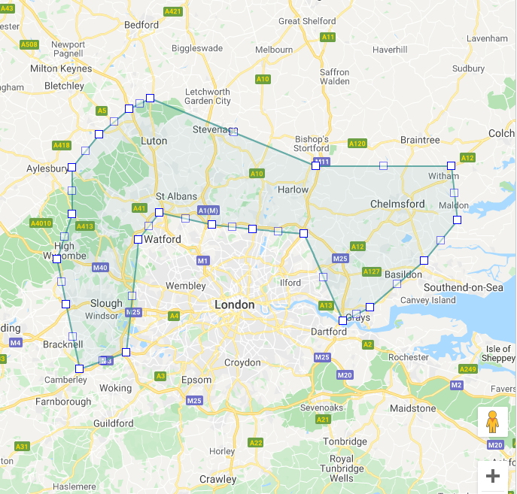

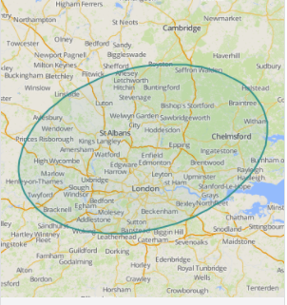

I started analysing right moves website information but I have come to realisation that there is not enough numerical data to compare and explore. Zoopla.com provides more numerical information for analysis such as distance to nearest station and nearest station to property.